**Cell Biology and Biochemistry**

**Workbook**

Student Name:

Tutor:

Submission Date:

**How to complete this workbook:**

Work through each answer in the workbook as you go. If you run out of space, simply use one of the additional sheets to record your answer. Remember to add your name and the question number.

Remember to show your working out for each question!

You MUST answer ALL of the questions.

|  |  |  |
| --- | --- | --- |
| **Q1** | Describe the differences between a Prokaryotic cell and a Eukaryotic cell. |  |
| 1.1 |
| Mark: |

**Q2**

Label the following diagram;

1.1

Mark:

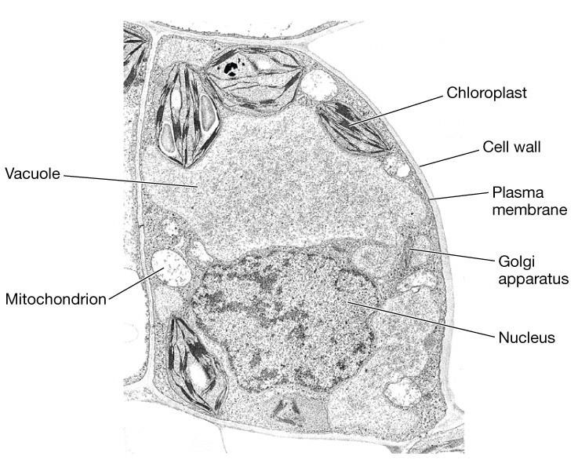

|  |  |  |
| --- | --- | --- |
| **Q3** | How large is the following cell? |  |
| 1.2 |
| Mark: |
| **Q4** | How large is the following organelle? |  |
| 1.2 |
| Mark: |

|  |  |  |
| --- | --- | --- |
| **Q3** | Complete the following chart; |  |
| 1.3 |
| Mark: |
| **Q6** | Identify the following tissue. What are the key specialist features of the cells in this tissue and how do they work together? |  |
| 1.3 |
| Mark: |

|  |  |  |
| --- | --- | --- |
| **Q7** | What is this organelle? What is it’s function? How does it’s structure help it function? |  |
| 2.1 |
| Mark: |
| **Q8** | What is this organelle? What is it’s function? How does it’s structure help it function? |  |
| 2.1 |
| Mark: |

|  |  |  |
| --- | --- | --- |
| **Q9** | What is this organelle? What is it’s function? How does it’s structure help it function? |  |
| 2.1 |
| Mark: |
| **Q10** | What is this organelle? What is it’s function? How does it’s structure help it function? |  |
| 2.1 |
| Mark: |

|  |  |  |
| --- | --- | --- |
| **Q7** | What is this organelle? What is it’s function? How does it’s structure help it function? |  |
| 2.1 |
| Mark: |
| **Q8** | What is this organelle? What is it’s function? How does it’s structure help it function? |  |
| 2.1 |
| Mark: |

|  |  |  |
| --- | --- | --- |
| **Q11** | What is this organelle? What is it’s function? How does it’s structure help it function? |  |
| 2.1 |
| Mark: |
| **Q12** | Match the correct molecule to the structure;  Protein  Fat  Carbohydrate |  |
| 3.1 |
| Mark: |

|  |  |  |
| --- | --- | --- |
| **Q13** | Compare the differences in structure between  Carbohydrates, Lipids and Proteins and explain how their different structures help them function. |  |
| 3.1 |
| Mark: |

|  |  |  |
| --- | --- | --- |
| **Q14** | Explain the formation and breakdown of polymers. |  |
| 3.1 |
| Mark: |

9 10

**Access to Higher Education**

**Diploma Nursing & Midwifery**

**Student Name: Sheet Number:**

|  |  |  |
| --- | --- | --- |
| **Q.** |  |  |
|  |
| Mark: |

11

**Access to Higher Education**

**Diploma Nursing & Midwifery**

**Student Name: Sheet Number:**

|  |  |  |
| --- | --- | --- |
| **Q.** |  |  |
|  |
| Mark: |

12