The Ready-to-Eat Breakfast Cereal Industry in 1994

(B)

Within a week of General Mills' April 1994 announcement that it intended to reduce spending on trade promotions and coupons by $175 million, Kellogg reaffirmed its intention to reduce promotional spending from 1993 levels. However, as in its past statements, Kellogg declined to give specific dollar figures for its reduction in promotional spending.¹ Prior to General Mills’ announcement, Quaker had raised the price of its Cap'n Crunch brand by about two percent and stated that it planned to use this increase to fund additional promotional spending. When asked about how Quaker would respond to the announcements by General Mills and Kellogg, company spokesman Ronald Bottrell replied, "I don't think you're going to have any announcement from us regarding pricing immediately. We're going to be watching this with interest to see what the reaction is."² Philip Morris, which had followed Kellogg's recent price hikes with its own announced increases, stated that it too was "studying the situation."³

Industry observers generally applauded the announcements by General Mills and Kellogg. However, several months after the announcements, some were concerned that other companies might not follow their lead, choosing instead to pursue market share growth aggressively, at the expense of the firms that had scaled back promotions. Analyst Nomi Ghez said, “We are encouraged by the growing realization of both Kellogg and General Mills that couponing and trade promotions have been overdone and are a highly inefficient way of doing business. However, we are not convinced that it will be easy to create the right balance between the spending intentions and the market share aspirations of all the market participants.”⁴

¹"Kellogg Co. Won't Change Cereal Prices," Reuters, April 7, 1994.
²Patricia Commins, "Talking Point/Cereal Makers on Price Offensive," Reuters, April 5, 1994.
³"General Mills slashes budget for inefficient promotions; cereal products marketing," Milling and Baking News, April 12, 1994, p. 1.

⁴Eric Palmer, "Seeking the Proper Balance; Players Make Changes in Promotion, Couponing," Milling and Baking News, June 21, 1994, pp.28.

Professor Kenneth S. Corts prepared this case with the assistance of Research Associate Amy L. Sandler MBA ’96 as the basis for class discussion rather than to illustrate either effective or ineffective handling of an administrative situation.

Copyright © 1996 by the President and Fellows of Harvard College. To order copies or request permission to reproduce materials, call 1-800-545-7685 or write Harvard Business School Publishing, Boston, MA 02163. No part of this publication may be reproduced, stored in a retrieval system, used in a spreadsheet, or transmitted in any form or by any means—electronic, mechanical, photocopying, recording, or otherwise—without the permission of Harvard Business School.

1

According to one cereal buyer, the reduction in promotional spending "will have a bigger effect if the other big player and the smaller players follow suit.... All indicators now look like they're not going to. In fact, they might even increase spending."⁵

Already somewhat vulnerable to market share incursions by competitors because of its risky push to rationalize industry pricing, General Mills took an additional, unexpected hit to its sales volume and market share in the summer of 1994. In June, General Mills announced that a supplier of oat flour, a critical ingredient in many of its cereals including the entire Cheerios line, had purchased oats from farmers who had used Dursban—a pesticide not licensed by the FDA. This discovery required the destruction of a large quantity of cereal and led to shortfalls of some of General Mills’ most popular brands through the summer and early fall of 1994.

As third quarter results became available in October, it was clear that other cereal companies were in fact seeking to take advantage of General Mills' and Kellogg's reduced promotions. The fraction of Post’s sales made under promotions had soared by 50% since General Mills’ April announcement; the figure for Quaker was nearly 20%. Exhibit 1 shows each company’s fraction of sales made with some trade promotional activity (including special displays, cooperative local advertising features, and price discounts in excess of 5%, but not including consumer promotions like couponing) relative to its 1993 average. While there were reports in the industry that Philip Morris was discontinuing its most costly promotions—including BOGOs—early in the fourth quarter, it was clear nonetheless that the sheer volume of promotional activity was continuing to increase. One trade publication reported:

With the two giants of the cereal world making good on their promises to cut back on promotions, smaller players are scurrying to gain market share with price specials and give-aways.... Kellogg said Friday that its decision to cut back on deep-discount coupons and freebies took a big spoonful out of its third-quarter sales of Frosted Flakes and other brands. This could prompt it to dish up more big-savings promotions in the future, industry analysts say, to attract consumers who show little brand loyalty.... For now, Kellogg says it is sticking to a pledge made earlier this year of cutting back on promotional spending....⁶

While General Mills’ results were difficult to interpret because of the Dursban incident, it was clear that the imbalance of promotional activity in favor of the smaller players was taking its toll on Kellogg and General Mills. Exhibit 2 shows changes in net prices and volumes a full year after General Mills’ announcent. First quarter 1995 results not only showed Philip Morris and Quaker gaining share at the expense of Kellogg and General Mills, it also showed the first year-to-year volume decline in recent memory for the cereal industry as a whole.

Other notable activity in the first quarter of 1995 included General Mills’ spin-off of its restaurant divisions from its core branded food business and Kellogg’s decision to forgo its traditional start-of-the-year price hike. Perhaps more importantly, Quaker announced in January that it would introduce a value-priced line of bagged cereals under the Quaker brand name. The lines to be introduced included knock-offs of many popular brands, not including, of course, Quaker’s own

Cap’n Crunch cereals.

⁵Bob Bauer, "Bowled Strategy: Retailers are Ready to Adjust if the Cutback in Promotions Started by General Mills Sets Trend; Breakfast Cereals," Supermarket News, May 16, 1994, p. 47.

⁶Patricia Commins, "Kellogg Hurt by Promotion Cuts, Consumers May See Change," The Reuter Business Report, October 21, 1994.

2

Exhibit 1 Fraction of RTE Cereal Sales Under Promotions

 | 20
1993 average | 15
1993 average | 10
to | 10
relative |  |  |  |  | Kellogg
relative | 5 |  |  |  | General Mills
promotion | 5 |  |  |  | Philip Morris
promotion |  |  |  |  | Quaker Oats
promotion | 0
under | 1Q94 | 2Q94 | 3Q94 | 4Q94 | 1Q95
% sales | -5
 | -10
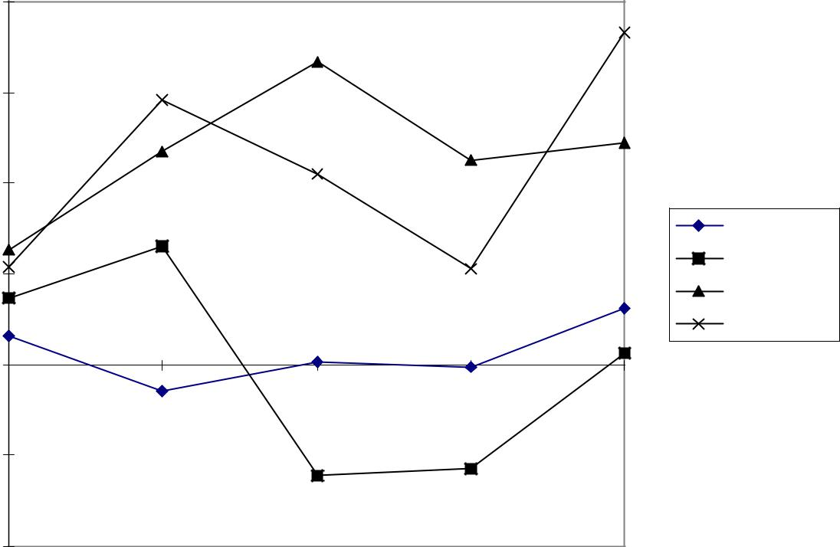

3

Exhibit 2 RTE Cereal Price and Volume Changes

Year ending 1Q95 | Change in |  | Change in | Volume | Volume Market
 |  | Net price | Volume | Share | Share change
Kellogg |  | 7.0% | -3.0% | 34.9% | -0.6
General Mills |  | -0.7 | -5.4 | 23.1 | -1.2
Philip Morris (Post/Nabisco) |  | 3.2 | 3.5 | 16.1 | +0.6
Quaker Oats |  | 1.3 | 10.8 | 8.6 | +0.9
Private Label |  | 2.0 | 9.1 | 10.3 | +0.9
Total Cold Cereal |  | +2.2% | -0.5%

Source: Goldman Sachs RTE Cereal Update.

4

