Assignment Two
Labour Economics (Economics 3341)
Winter 2018

Issued: March 21st, 2018
Due: March 28th, 2018 on BrightSpace

Answer each of the following questions in full sentences. Use a graph if it helps with your explanation.

- Explain the issue of “omitted skill variables” in relation to wage discrimination. Explain why you think this is or is not an important.
- Given the following table, draw and explain the step demand curve for female labour.
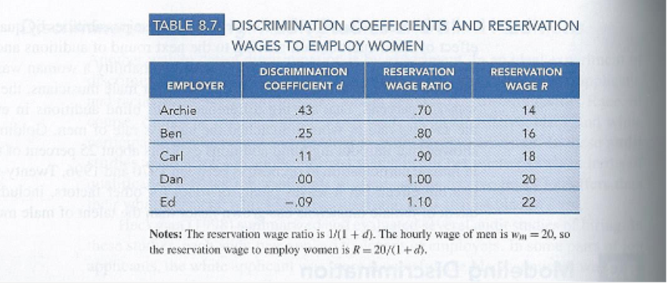
- Explain Marshall’s Rules of Unions.
- Explain the Threat Effect of Unions.
- Explain the Lorenz Curve and the Gini Coefficient. Use a graph and explain why they are important.

Good Luck

