Roles Of RFID Technology In The Management Of Supermarkets' Stores

How to develop research topic
It is expected and natural to have an issue in developing the research topic considering that there are a plethora of issues which one may be wishing to address in the studies. I have to note that was overwhelmed by the hundreds of the studies which exists on the internet and the library databases, literature reviews as well as references pages as I had a difficult time to make a decision on which topic to select out of the several themes which were available. I had to compete with different hopes the research project may bring considering the different themes I was thinking about. Although it was overwhelming, the various themes which I had highlighted gave me much insight into the general issue of the role of the RFID technology in improving productivity within the organization. It also gave me a great approach to learn more about the significance of technology in the day to day business operations. However, as a researcher and writer who is creative and engages in critical thinking skills, I had to dive more deeply into a topic which is less researched but has a vast pool of knowledge.
Because topics related with the information technology is broad, it is natural to spend many days and weeks searching for a specific topic which could enable me to provide the solutions to the issues related to the theme. It was also important to note that no matter how great or small the scope of the study is, as a serious and competent researcher, I had to reserve adequate and appropriate period to conduct a thorough or explicit survey of different published and peer-reviewed resources before making a decision on the best and suitable topic. Specifically, I used seven research topics to identify the different themes before narrowing them down into a single question of research.
From all the research articles I evaluated, I came up with various themes which were all geared towards finding organization solutions through the use of technology. This is when I now had to consider a specific topic which I was strongly interested in. I had to eliminate all the other topics which I found challenging to understand and also uninteresting to me. This was one the first method I used to narrow down the research topic. It is also notable that I was fascinated by the Radio-Frequency Identification (RFID) technology after reading several articles concerning this new technology. I could not stop thinking writing and research more about the new technology and how it can be useful in the modern business world.
Moreover, the decision to select this research topic was enhanced because of its creative nature. We have to agree that there are other studies done on the topic and I had to find another way of making it more unique and appealing to both my peers or classmates and the instructors. The creativity of the topic can be seen from the inclusion of the various important components or elements which drives the productivity of any business. Typically, the integration of supply chains management tenets such as inventory and quality management made the topic to be unique and creative. The role of the Radio-Frequency Identification (RFID) technology in enhancing the safety and security of the business also made the research topic to be more unique.
Last but not least, I had to ensure that the topic is not broad as the assignment prompt also guided me. Making the topic to be too broad could further complicate the research, and this could also lead to confusion and unreliable information from the research. Particularly, I choose the retail stores such as supermarkets in this study since it is always faced with the issues in its supply chain management and more specifically in the managing its quality, inventory, and security.
Concept mapping of key ideas
The development of the concept map not only evaluated the research topic among other dreadful tasks or activities easier but also saved me a lot of time. A concept map is a diagram which visually displays information. After identifying the topic of my research, which is the role of RFID technology in the supermarkets, I came out with four key questions. For instance, I asked myself what aspects of the research question I wanted to study before providing a solution to the question of where the topic which is related to the topic is concerned with the retail stores. I also thought about examining the significance of RFID in the inventory management in the supermarkets. The relevant stakeholders who are affected by the topic were also highlighted in this section of the concept map. Lastly, I had to examine why these issues are indeed a major problem and the reasons why they should urgently address. These four key questions led to the development of more components or branches in the concept map.
Particularly, the four major branches which were also integrated into the research topic include the management of inventory and quality along with the security of the supermarkets. In the quality management, I highlighted ways in which the RFID technology could ensure increased quality in the retail stores such as supermarkets. The RFID technology led to internal service quality which also made me think about workplace design, job design as well as tools for serving the clients within the retail store. The internal service quality also resulted in the satisfaction of employees after their performance measurement and analysis of their feed-backs. Similarly, the employee satisfaction resulted in the increased retention of the workforce along with the improved productivity of the employees. On the external value of quality, I highlighted the increased satisfaction of the clients which also led to the retention, repeat business and referral. The external value of quality also resulted in the improved loyalty of the customers, and this resulted in the increased revenue and improved profitability of the business. However, on the inventory management, I identified the role of smart labels in enhancing the automatic identification in the stores or warehouses as well as the outlets. The concept of shelf stocking together with in-store product replenishment was also identified. The topic of inventory management ended by explaining the effects of RFID technology in reducing the overhead costs through improvement of shipping along with the receiving processes and the elimination of human error during the supply chain management activities. Nonetheless, the topic of security resulted in multiple branches which are geared towards ensuring the safety and security of organization’s stocks. Another vital branch or concept which was developed out of this topic is how the Radio-Frequency Identification (RFID) technology can be used to curb shoplifting in the supermarkets. Some of the privacy and security issues which needs to be addressed by the Radio-Frequency Identification (RFID) technology also formed the next branch of the security topic (Lopez-Carmona et al., 2010).

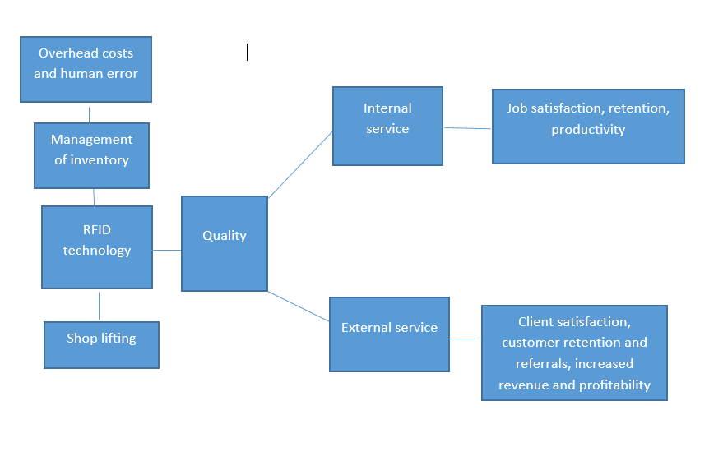
Figure: Research Map
Perspective on the topic
The integration and use of Radio-Frequency Identification (RFID) technology are rapidly growing across various industries. The manufacturers or developers of this technology have made it have the ability both manage the inventory and quality as well as the security issues such as electronic passports within the organization.
It is also notable that the Radio-Frequency Identification (RFID) technology can establish strategic advantage at the same time improve the quality of customer service. After Walmart and the Department of Defense decided to move to a higher level as an approach and tool of enhancing the supply chain management and operations, the technology has since been an effective and efficient mechanism for both the internal and external clients in different organizations (Knežević et al., 2005). While the use of the Radio-Frequency Identification (RFID) technology in a variety of business applications has been around for more than two decades, its emerging usage as an automatic identification has shifted into a different logistics. It is evident that the modern applications of the Radio-Frequency Identification (RFID) technology range from life savings in the health facilities through tracking of patients, tools, and workforce at one given end of the spectrum to the improvement of the inventory management as well as the production operations at the other part of the spectrum.

References
Knežević, B., Delić, M., & Cegnar, M. (2015). BENEFITS AND RISKS OF RFID TECHNOLOGY IN RETAIL FROM THE YOUNGER CONSUMERS'POINT OF VIEW. Business Logistics in Modern Management.
Lopez-Carmona, M. A., Marsa-Maestre, I., De la Hoz, E., & Velasco, J. R. (2010). Using RFID to enhance security in off-site data storage. Sensors, 10(9), 8010-8027.
Michael, K., & McCathie, L. (2005, July). The pros and cons of RFID in supply chain management. In Mobile Business, 2005. ICMB 2005. International Conference on (pp. 623-629). IEEE.
Rekik, Y. (2006). The impact of the RFID technology in improving performance of inventory systems subject to inaccuracies (Doctoral dissertation, Ecole Centrale Paris).
Sardroud, J. M. (2012). Influence of RFID technology on automated management of construction materials and components. Scientia Iranica, 19(3), 381-392.

