- File Types doc, docx, and, and pdf

- Available Jun 28 at 11:59pm - Jul 8 at 11:59pm 10 days

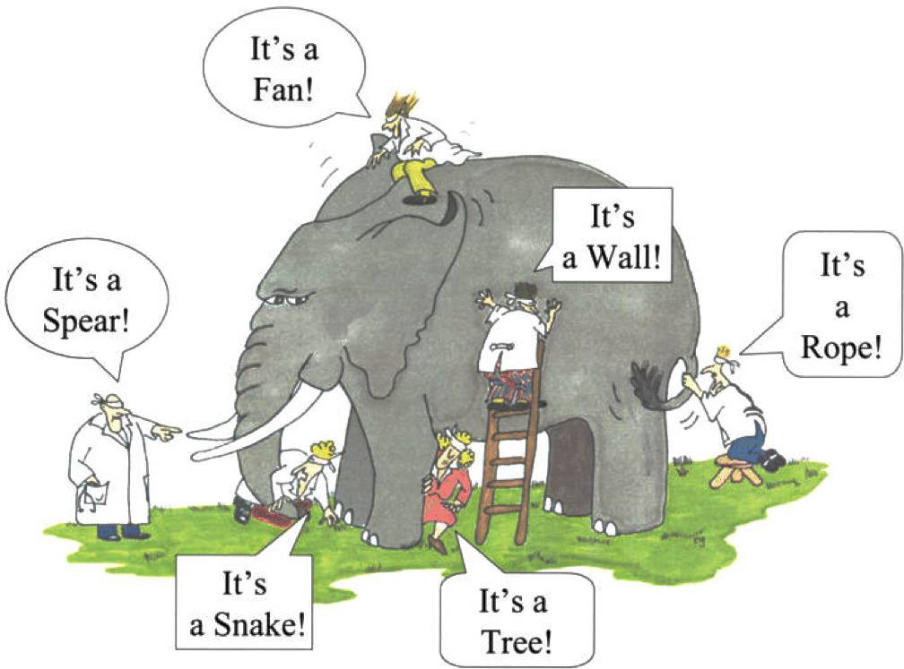

Essay #2: An Epistemological Adventure in Perspectivism

Warm Up
In the beginning of Jane Tompkins' "Indians, Textualism, Morality, and the Problem of History," after providing some context for her relationship to the subject at hand, she identifies and describes a specific problem that must be resolved. She asserts that it "concerns the difference point of view makes when people are giving accounts of events, whether first or second hand. The problem is that if all accounts of events are determined through and through by the observer's fame of reference, then one will never know, in any given case, what really happened" (Tompkins 102). She then takes her reluctant readers (colleagues on the other side of the "theory wars") on an adventure through extensive research of secondary and primary sources--even firsthand accounts--which help her to identify the problem and discover much about herself. Ultimately, she formulates a solution based on analyzing and evaluating a variety of sources. In essence, she synthesizes the knowlege and experience to come to a conclusion, that "Reasons must be given, evidence adduced, authorities cited, and analogies drawn. Being aware that facts are motivated, believing that people are always operating in side some particular framework or other [including theory and worldview] is a pertinent argument when what is under discussion is the way beliefs are grounded. But it doesn't give one leverage on the facts of a particular case (Tompkins 118). Tompkins uses inductive reasoning and clever argumentation to persuade her reluctant reader that one can come to a sufficient truth on which to make moral judgements on issues that require them. Finally, she resolves "What this means for the problem I've been addressing is that I must piece together the story of European-Indian relationships as best I can, believing this version up to a point, that version not at all, another almost entirely, according to what seems reasonable and plausible, given everything else that I know" (Tompkins 118). This is her conclusion/major claim, one that she may have had trouble arriving at without research, and one she would have been less likely to convince her reluctant reader of if she had not taken them through her epistemological adventure.
Now it is your turn to "piece together" your objective research on a current question or issue facing this issue. Once you have determined your conclusion, you will work to persuade a reluctant/resistant reader to consider (maybe even accept) your position. Through your close work with Tompkins' text, you were introduced to a nuanced, inductive argument--something you are now challenged to do. Tompkins, in particular, provides an excellent model for the project you are about to undertake.

Directions
- From the list below, choose ONE of the questions/problems facing the United States. I have identified the issue and provided you with one or two sources, which you must use in your paper. In one case, I provide an optional source.
- While you may already have a position, do not formulate your conclusion until thoroughly researching a diversity of perspectives on the issue. Practice the critical thinking skills you have learned in this module and keep an open mind.Give yourself over to the research and the process of discovery--about the issue and about yourself. Tompkins shares a lot with her readers, and this in turn strengthens her argument.
- Conduct extensive research on the question/problem (primary, secondary, and tertiary sources) and then narrow them down to best represent a diversity of perspectives in your paper. You are not restricted to U.S. sources.
- Once you determine your conclusion/major claim, identify your audience, which should be uninformedand/or resistant to your position. Like Tompkins, you are going to take them through your research to lead them to your conclusion.
- Use inductive reasoning and Tompkins' structure as a model for the writing of your essay:
  - narrate history and personal relationship (experiential, observational, and or intellectual) to the question/problem;
  - establish broader, national context for question/problem;
  - present/define question/problem;
  - summarize, analyze, and evaluate select research representing a diversity of perspectives;
  - synthesize response to research;
  - present your conclusion, your resolution or solution to the question/problem (which may side with one or more of your sources), and provide reasons and evidence to support it;
  - if applicable, share any new question/s or problem/s encountered as a result of your research and critical thinking (as Tompkins did in her last paragraph).
- Adapt Tompkins' style and tone with your own; it is particularly effective for a resistant audience, a way of showing (rather than "telling") and persuading them to arrive at your conclusion. Yes, you may use "I," as you are taking your audience through your epistemological adventure, but be strategic with it.
- Note: Rarely is this type of argument meant to utterly convince an audience; in fact, it is enough to just get a resistant audience to reconsider their own position/perspective in light of your own. One might also say that many people do not have fully informed opinions on subjects--this paper counters that. Arguments at this level are not about "winning," and this is not a course in debate.
List of Contemporary Questions/Problems Facing the United States (you must choose one):
While the Grossmont College Databases are excellent and should be used, you should also have no problem finding a plethora of perspectives on any of these current questions and problems.
- Should the United States provide reparations for slavery? "The Case for Reparations" (Links to an external site.)Links to an external site. by Ta-Nehisi Coates
- Should Confederate monuments be removed from public spaces? "Confederate Statues Honor Timeless Virtues--Let them Stay" (Links to an external site.)Links to an external site. by Arthur Herman
- Migrants at Southern Border. "What We Know: Family Separation And 'Zero Tolerance' At The Border" (Links to an external site.)Links to an external site. by Camila Domonoske and Richard Gonzales
- Trade Wars. "The President's 2017 Trade Policy Agenda" (Links to an external site.)Links to an external site.
- Is Hip-Hop harmful? Both of these sources must be used: "Can Hip-Hop Inspire a New Generation of Architects?" (Links to an external site.)Links to an external site.and "Jazz Trumpeter Wynton Marsalis Calls Rap Music 'more damaging than a statue of Robert E. Lee'," (Links to an external site.)Links to an external site. by Ben Kaye. One more optional source you might want to include:"This Is America," (Links to an external site.)Links to an external site.by Childish Gambino.

Requirements
Final essay should be:
- a clear response to the directions;
- 8-12 pages in length;
- in correct MLA format and style, including in-text citations and the Works Cited page (do not include a cover page);
- well organized with effective transitions between ideas and paragraphs;
- efficient with regards to close work with sources, including, but not limited to, precise and concise summary and the smooth integration of direct quotes, block quotes, and paraphrases;
- the product of original, deep critical thinking, both with regards to content and form.
- meticulously proofread and primarily free of sentence-level errors;
- contain a minimum of eight sources (including the one I have provided).


This essay will be run through VeriCite. The program ensures originality by comparing submissions to billions of sources of academic content, publisher’s content, and against your own submissions—far beyond just Grossmont and Cuyamaca. Papers receiving a VeriCite score over 15% may result in a zero on the assignment and academic probation from the college. A VeriCite report on an essay below 15% is usually acceptable A high plagiarism percentage on VeriCite is typically over 25% (yellow, orange or red), and it almost always represents academic fraud. Please do your own work, handle your sources responsibly, and contact me if you have any questions or concerns.

Additional Resources
For this assignment, I assume you know how to do college-level research. If you feel as though your last English course did not prepare you for the type of research and critical work with sources required by this assignment, below are some resources you may find helpful:
- Grossmont College Online Tutorial: LUCI (Links to an external site.)Links to an external site. (Library User Computer Instruction).
- Grossmont College Citation Help (Links to an external site.)Links to an external site.
- Grossmont College Databases (Links to an external site.)Links to an external site.(Opposing Viewpoints is an exceptional database for this type of paper).
- Top Ten Tips for Doing E-Research at College (Links to an external site.)Links to an external site.& Eight More Tips (Links to an external site.)Links to an external site.
- What is Evidence? (Links to an external site.)Links to an external site.
- MLA Style: Integrating Sources: MLA-Integrating-Sources-Handout.pdf

On the next page, I have created a Discussion Forum for you to ask questions, both of me and your peers, share ideas, research, challenges, and anything else related to this project. Please use it! Moreover, I prefer you ask me questions there, rather than by email, as your question/s may be shared by your peers and my answer may benefit them as well. You have no idea how much I am looking forward to reading this papers. Relax. Go for it. This is thrilling stuff...

Rubric
Rubric for Essay #2
Rubric for Essay #2
Criteria | Ratings | Pts
This criterion is linked to a Learning OutcomeThe essay is a clear response to the directions. |  | 50.0 pts
This criterion is linked to a Learning OutcomeThe essay is 8-12 pages in length. Long block quotes are not used to meet page count. |  | 20.0 pts
This criterion is linked to a Learning OutcomeThe essay is in correct MLA format and style, including in-text citations and the Works Cited page (a cover page is not included). |  | 30.0 pts
This criterion is linked to a Learning OutcomeThe essay is well organized with effective transitions between ideas and paragraphs. |  | 30.0 pts
This criterion is linked to a Learning OutcomeThe essay is efficient with regards to close work with sources, including, but not limited to, precise and concise summary and the smooth integration of direct quotes, block quotes, and paraphrases. |  | 30.0 pts
This criterion is linked to a Learning OutcomeThe essay is the product of original, deep critical thinking, both with regards to content and form. |  | 30.0 pts
This criterion is linked to a Learning OutcomeThe essay is meticulously proofread and primarily free of sentence-level errors. |  | 30.0 pts
This criterion is linked to a Learning OutcomeThe essay contains a minimum of eight sources, including the one/two required. |  | 30.0 pts
Total Points: 250.0

