http://libguides.wvu.edu/english101

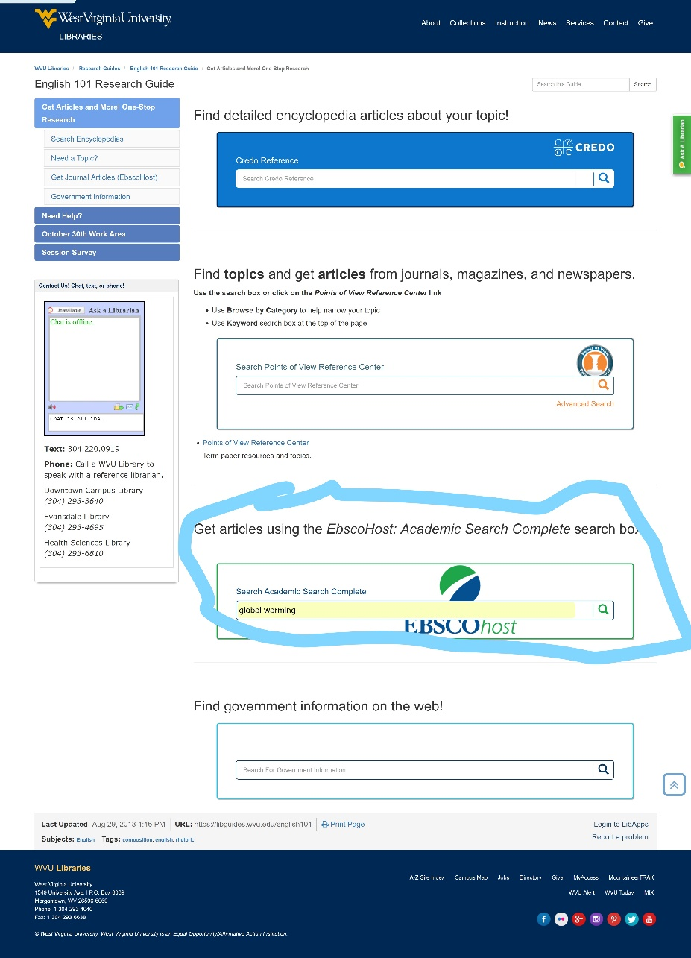

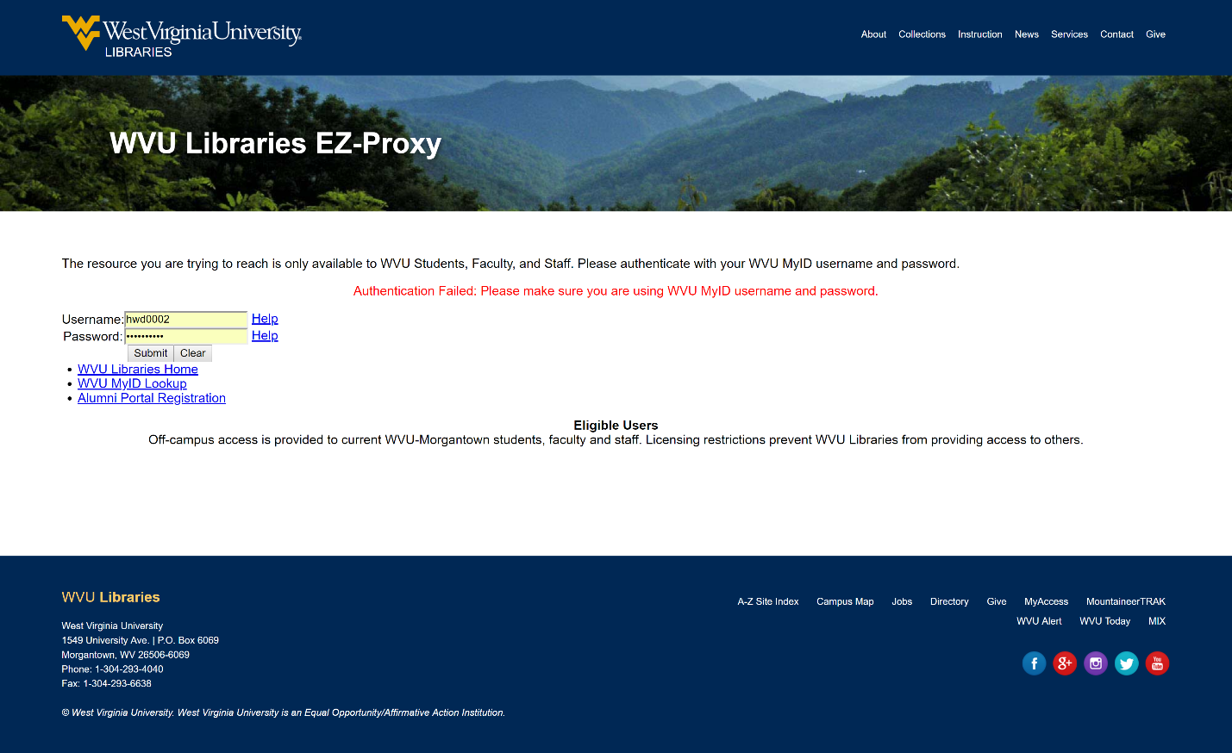

Username : hwd0002
Password : Supreme321

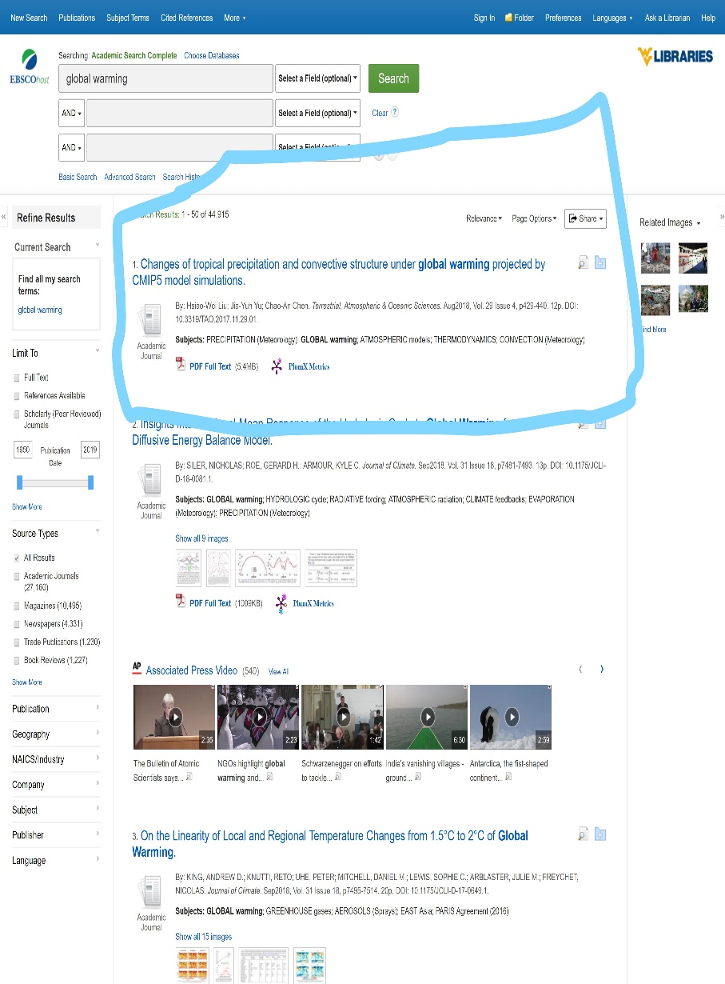
lets say you chose this source
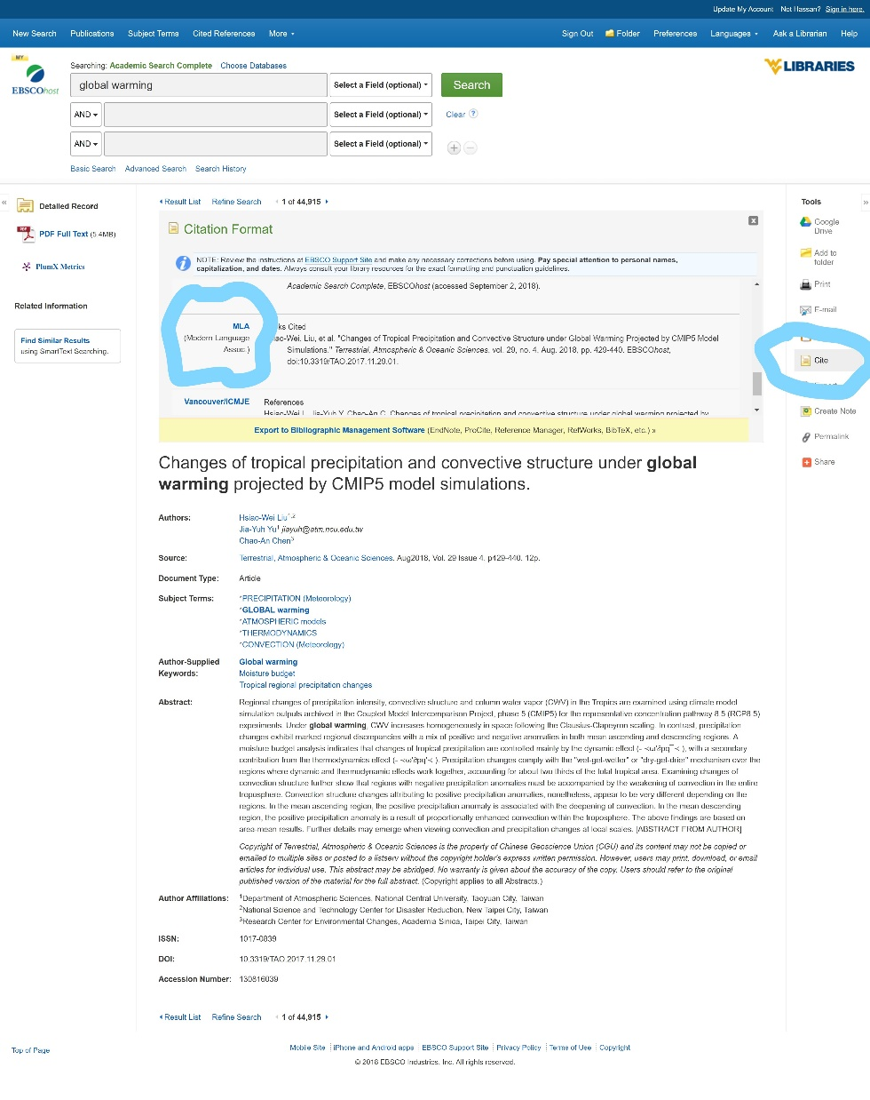

Go to the cite tab and copy and paste MLA format +plus the URL link for the page

Thank you !!!!!!

