Coca-Cola is an example of a company that utilizes automated warehousing strategy. In recent years they have worked at expanding many of their distribution centers to automation in various ways. In 2017, Coca-Cola Malaysia invested $119 million to expand size and production of its plant by hiring Swisslog for robitic warehouse intralogistics. This new system sychnornoized automated systems with people and process Tao 2017).
Also in 2017, Coca-Cola Singapore invested $57.5 million into a storage and distribution center. This center was Singapore's first center to utilize automated storage and retrieval that was built on top of loading bays and therefore used half the space than what would typically be used in a distribution center. In both of these situations Coca-Cola built brand new buildings and centers to invest in this automation rather than changing existing warehouses. They took into account environmental and safety issues when doing so. The center in Singapore was awarded Leadership in Energy & Environmental design and Green Mark Gold Certification (Journey 2017).
Below are images from their warehouses:
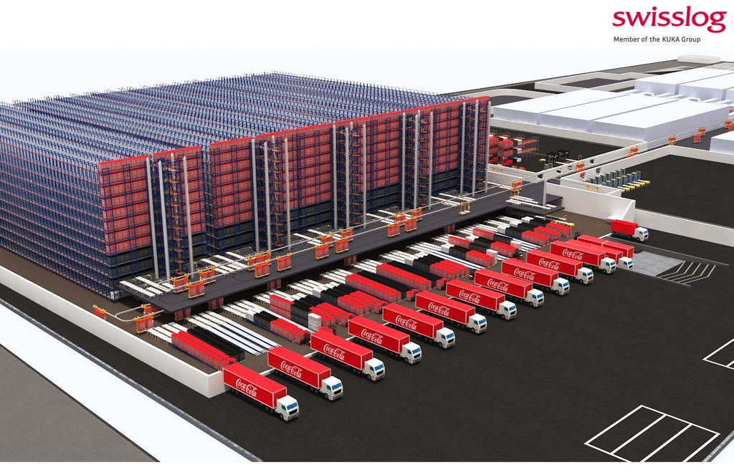
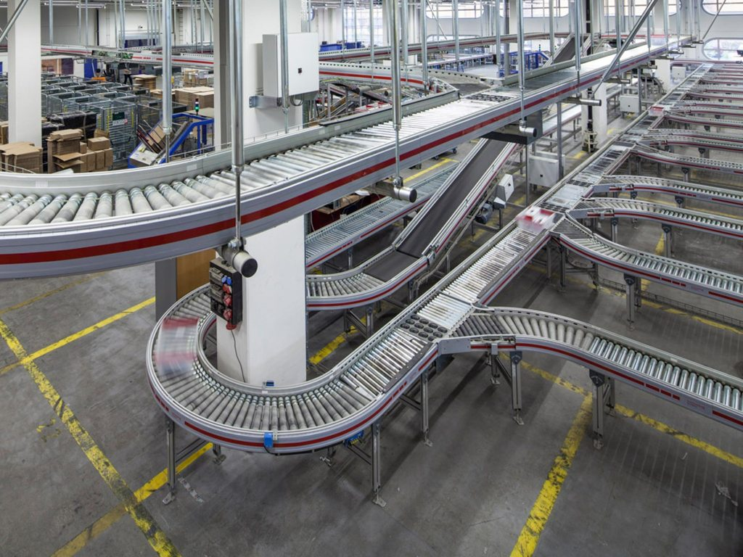
References:
Journey (2017 July 2018). "Coca-Cola opens state-of-the -art storage and distribution center in Singapore". Retrieved by: https://www.coca-colacompany.com/stories/coca-cola-opens-state-of-the-art-storage-and-distribution-center
Tao, M. (2017 September 7). "Coca-Cola order robotic warehouse system from SwissLog". Retrieved by: https://roboticsandautomationnews.com/2017/09/07/coca-cola-orders-robotic-warehouse-system-from-swisslog/13978/

